Final Wrap-Up Report
  - (El_exito Fragrances)

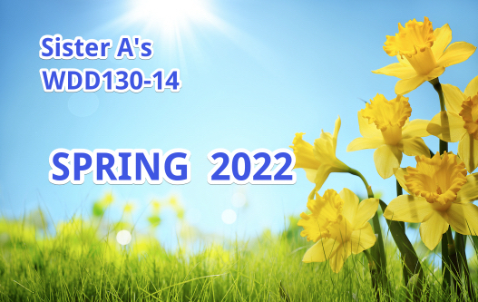

OGHENEKOME VICTORY IGHO
WDD130 – 14
July 2022

Introduction:
Do you know that good scents steal the show? And the ultimate code of seduction is a great fragrance of perfume sprays, scented candles and perfume oils. In a society where we have to work so hard and make out time to socialize, it is important that we wear a perfect scent for the show. Elexito Fragrance perfume spray is a perfume product for both men and women without discrepancy, each of our product is urban, trendy and different.

\Purpose of my website
- Serve as a means to generate more revenue for this business.
- To give users access to the lists of all our products and services.
- From this website people can join a community where they can share opinions on fashion and social lifestyles.
- Place orders for Branding gifts for people for special occasions.

Target Audience
- This website is created to give access to people with love for good scents. Anyone with access to the internet and love the idea of a mild classy, strong classy perfume scent. People from every work of life, early teenage and adults who likes to catch attention with the scent they wear.
- People who have little income can also buy designers perfume oil from our offline store. People also who have interest in selling our products, can get information on plans set aside from the website.
- People with need for a scent that does not transcend to describing your gender, but also tell something about your personality.
- The target audience will get access to our website from anywhere they are, from their cell phone, laptop, desktop, so long they have access to the internet.

My Website URL
https://glitch.com/edit/#!/dusty-invented-catmint?path=e%27lexito%2Findex.html%3A69%3A42

Website goals and objectives

El_exito fragrances gives fragrances worth remembering for a lifetime and Our mission is to make the world more beautiful one scent at a time. This website will give visitors a feel of our primary goals and objectives. Giving rise to creating more revenue to expanding the business, meeting the need of our customers and also, empowering people with a means to also earn from choosing to partner with the brand.

Design Process

This website was created following this design process;
- Identified the goal: This process involved identifying the goals of this website, putting into consideration, the stakeholders and anyone the website affects directly or indirectly.
- Defined the scope: The process involved setting a scope for the website, what and what will be created and what will not be created to avoid ambiguity during the design process.
- Created sitemap and wireframe: This process was the foundation upon which the site was created. Here ideas of how the site flows and connect between each page were defined. The wireframe for this site was created with a site mapping tool.
- Created the contents for the webpages: The process involved creating written content for the website. This is to keep visitors engaged on the webpage and also drive us to fulfilling the site goal.
- Created and added visual elements: This process involved creating visual styles for the website. Following the existing branding elements, color choice and logo according to client specifications.
- Tested The site: This process is to ensure that everything works fine, all links are working and the website loads properly on all devices and browser. A check with W3C link checker was done to check the validity of the website link also.

Conclusion and What I learned

Although, before building the website, every idea was rightly planned for, sketches were made and the contents were laid out. But while I was putting together this website, there were changes made in the concept, content, navigation and some other things. Since it was my first personal webpage, I struggled to put everything into perspective and linking pages properly. I changed plans for some areas, especially around on my home page and on my fragrance page. Added a few text and it started to make sense.

One major lesson I learned is that one should be open to changes for the best performance of the website. Also, keen consideration should be given to functionality. Every click, every scroll, should have a function as much as it is beautiful.

